Date: 12 Feb, 2014 M.S. Raghavendra Sriram

1000854840

EE 5322 Intelligent Control Systems

Assignment no 2

RLS and DFT Analysis

1. RLS System Identification

1. The input uk and output k y of a discrete time system are given in the data file. The system is of second order with a delay of d=2.

a. Write a RLS program to identify the system transfer function.

b. Plot the output k y and the output of your identified system given the input k u . They should be the same.

Solution :

clear all;close all;clc

FileName = ('Hw2.xls')

samples = xlsread(FileName);

x(:,4)=ones(4,1);

P=1000*eye(4);out=zeros(4,601);

sigv=1;

for i=4:601

out(:,i)=diag(P);

y(i)=samples((i),4)';

T1=[-samples((i-1),4) -samples((i-2),4)];

T2=[samples((i-2),3) samples(i-3,3)];

H(:,i)=[T1';T2'];

A = pinv(H(:,i)'*P*H(:,i)+sigv)

B = H(:,i)'*P;

P=P-P*H(:,i)*A*B;

x(:,i+1)=x(:,i)+P*H(:,i)*(y(i)-H(:,i)'*x(:,i))/sigv;

end

t=1:602;

plot(t,x(1,:),'r',t,x(2,:),'g',t,x(3,:),'b',t,x(4,:),'y');

grid on;

title('Convergence of coefficients')

figure(4)

plot(t(1:601),out(1,:),'r',t(1:601),out(2,:),'g',t(1:601),out(3,:),'b',t(1:601),out(4,:),'y');

grid on;

title('Convergence of error covariance');

clear y;

% The model is

coef=x(:,end)

y=zeros(601,1);

for i=40:250

if i < 4

y(i)=[-y(i) -y(i-1) samples((i-1),1) 0]*coef;

else

y(i)=[-y(i) -y(i-2) samples((i-2),1) samples((i-3),1)]*coef;

end

end

figure(5)

plot (t(1:601),y,'r');

hold on;

plot(t(1:601),samples(:,2),'--');

hold on;

title('Simulated output and Actual output');

Solution:

0.0000 0.0000 0.0000 0.0000 0.0000

0.0000 0.0000 0.0000 0.0000 0.0000

0.0000 0.0000 0.0001 0.1998 0.0000

-0.0723 0.0000 -0.0004 0.2011 0.3617

-0.7016 -0.3371 0.0061 0.1813 0.3038

-1.0146 -0.5643 0.0010 0.1968 0.1879

-1.8927 0.9388 0.0004 0.1997 0.0019

-1.8989 0.9485 0.0001 0.2000 0.0002

-1.8991 0.9486 0.0001 0.2001 0.0002

-1.8992 0.9486 0.0001 0.2001 0.0002

-1.8992 0.9487 0.0001 0.2001 0.0002

-1.8995 0.9493 0.0001 0.2000 0.0001

-1.8997 0.9495 0.0000 0.2000 0.0001

-1.8997 0.9497 0.0000 0.2000 0.0001

-1.8998 0.9497 0.0000 0.2000 0.0000

-1.8998 0.9497 0.0000 0.2000 0.0000

-1.8998 0.9498 0.0000 0.2000 0.0000

-1.8998 0.9498 0.0000 0.2000 0.0000..

.. -1.8999 0.9499 0.0000 0.2000 0.0000

-1.8999 0.9499 0.0000 0.2000 0.0000

-1.8999 0.9499 0.0000 0.2000 0.0000

-1.9000 0.9500 0.0000 0.2000 0.0000

-1.9000 0.9500 0.0000 0.2000 0.0000

-1.9000 0.9500 0.0000 0.2000 -0.0000

-1.9000 0.9500 0.0000 0.2000 -0.0000

-1.9000 0.9500 0.0000 0.2000 -0.0000

-1.9000 0.9500 0.0000 0.2000 0.0000

-1.9000 0.9500 0.0000 0.2000 0.0000

-1.9000 0.9500 0.0000 0.2000 -0.0000

-1.9000 0.9500 0.0000 0.2000 0.0000

-1.9000 0.9500 0.0000 0.2000 0.0000

-1.9000 0.9500 0.0000 0.2000 -0.0000

-1.9000 0.9500 0.0000 0.2000 -0.0000

-1.9000 0.9500 0.0000 0.2000 -0.0000

-1.9000 0.9500 0.0000 0.2000 -0.0000

-1.9000 0.9500 0.0000 0.2000 -0.0000

**The Co-efficients are -1.9000 0.9500 0.0000 0.2000 -0.0000**

Plots :

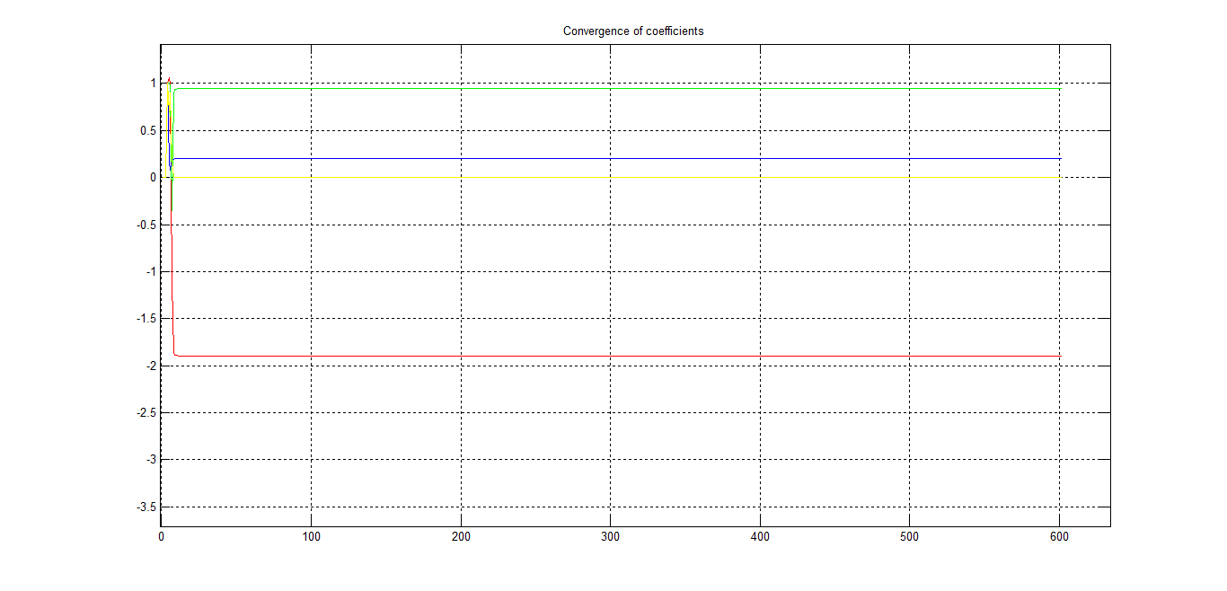

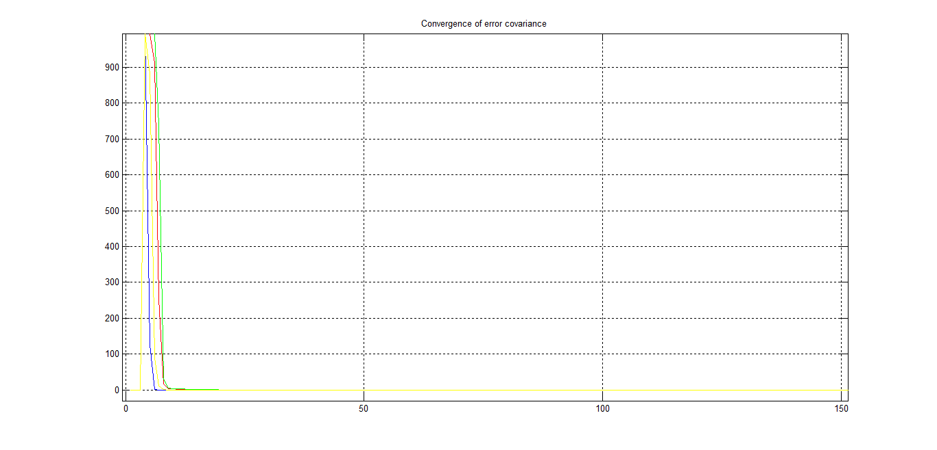

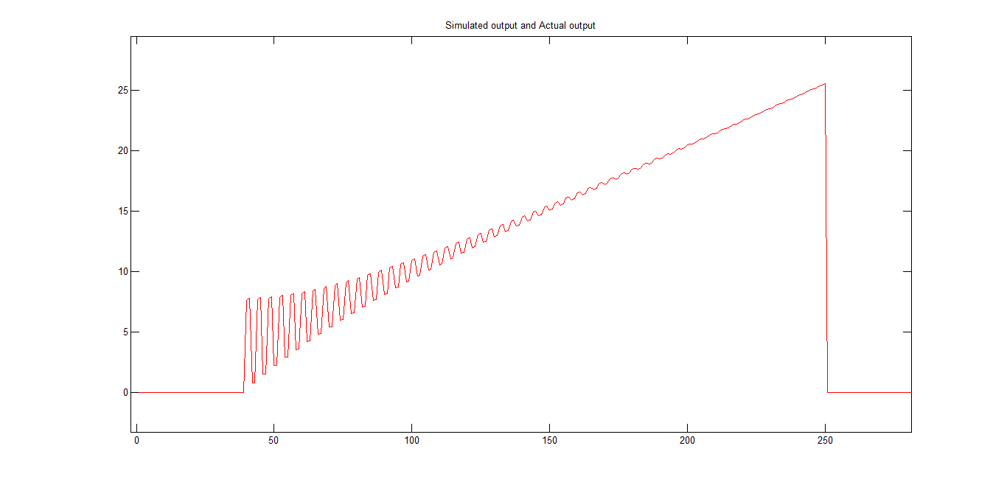

Digital Speech Processing

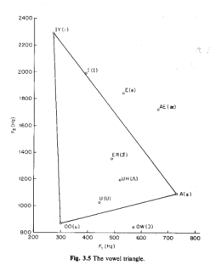

2. (The frequencies here are about 1/10 the actual values for ease of processing using MATLAB.)

In speech, the vowels are characterized by three main frequencies known as formants. The first two formants for each vowel in English are as follows: vowel Formant 1 (Hz) Formant 2 (Hz)

A 70 110

E 50 180

I 40 200

O 60 80

U 30 80

The data for this homework contains an 8 sec speech signal that contains some vowels. The sampling period is 1 msec= 0.001 sec. Chop the signal into eight bins of length 1 sec. In each bin, do the FFT (using N= a power of two). Determine which vowels occur and when. Finally, plot the DFT vs. time as a 3-D plot.

Code:

clc;

clear all;

close all;

FileName = ['homework 2 data 2.xls']

x = xlsread(FileName);

x2=x(:,3);

win=1000;k=1;

for i=1:8

k;

temp=k+win-1;

y(:,i)=fft(x2(k:k+win-1),1024);

py=y.*conj(y)/1024.*conj(y)/1024;

k=k+win;

figure(1)

subplot(2,4,i);

waterfall(abs(py'))

title('Iterations of DFT using Bin ');

hold on;

axis([0,100,0,10,0,400])

w=1000*(0:1023)/1024;

py=y.*conj(y)/1024.*conj(y)/1024.*conj(y)/1024.*conj(y)/1024.*conj(y)/1024;

figure(2)

plot3(ones(1,1024).*i,w',abs(py))

hold on

grid on;

title('DFT of Bins');

xlabel('second');

ylabel('Freq Hz');

zlabel('Magnitude');

end

Plot:

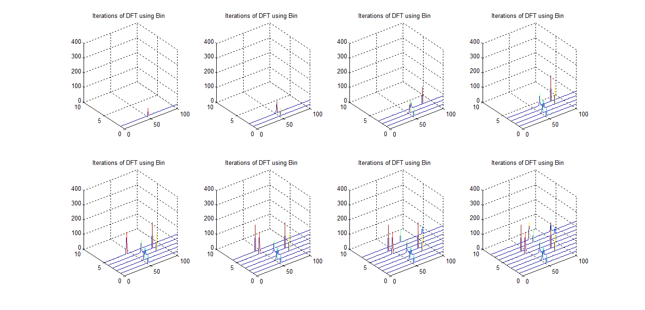

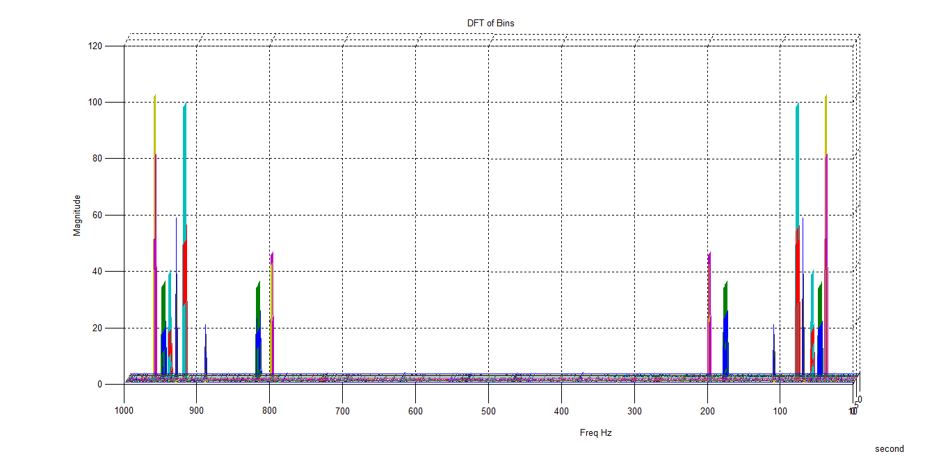

Machinery Monitoring

3. An induction motor drive has a base rotation frequency of 0f = 50 Hz, a frequency of 3 0f due to a three-bladed fan, and a component at 4 0f due to a 4:1 gearbox. When a certain pinion gear wears badly enough, a prominent frequency component of 277 Hz appears. Soon after that, the amplitude of the frequency component at 4 0f significantly increases due to the failure of a gear tooth. In the 6 sec data file, the sampling period is 1 msec. Find out when the two anomaly failure events occur. Plot the DFT vs. time as a 3-D plot. Use moving average window for the DFT of length ½ sec. Use N= a power of two

Solution:

clc;

clear all;

close all;

FileName = ['homework 2 data 3.xls']

samples = xlsread(FileName);

x = samples(:,3);

win=500;

time = 0.001;

for k = 500:6001

t=k-win+1;

y(:,k)=fft(x(t:k),512);

py(:,k)=y(:,k).*conj(y(:,k));

end

w=1000*(0:511)/512;

figure(1)

waterfall(w,x,abs(py)');

title('Iterations of DFT using moving window ');

hold on;

grid on;

title('DFT ');

xlabel('freq');

ylabel('time');

zlabel('DFT');

